Project Design Phase
Problem – Solution Fit Template
Date | 12 February 2026
Team ID | LTVIP2026TMIDS71782
Project Name | Optimizing User, Group, and Role Management with Access Control and Workflows
Maximum Marks | 4 Marks

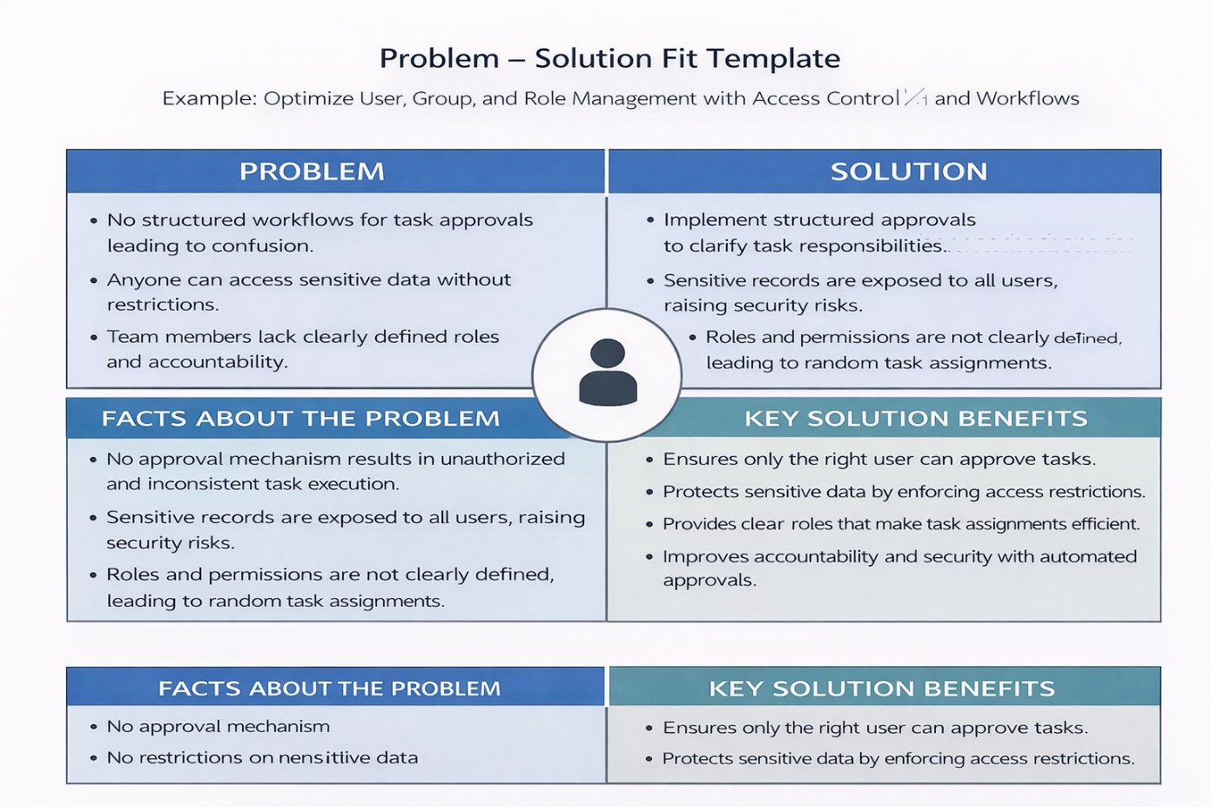
Problem – Solution Fit Template:

Template:
